***PAAREES PERFUMES***

***THIERRY MUGLER***

***FOR UNISEX***

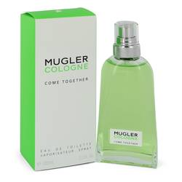

# 

# MUGLER COME TOGETHER

## *Description:*

Mugler Come Together by Thierry Mugler Perfume. Mugler Come Together perfume is a light, airy fragrance for women that is ideal for casual wear. Launched in 2018, this fresh, herbaceous aroma opens with a crisp top note of green petitgrain. This note give the perfume a strong herbal accord with an aromatic undertone. White musk completes this fragrance by grounding it with a light, aromatic. Made up of only these two notes, the aroma is simple and refreshing, making it light enough for everyday wear. The feminine scent may quickly become your favorite fragrance with its light sillage and longevity.